# **Types**

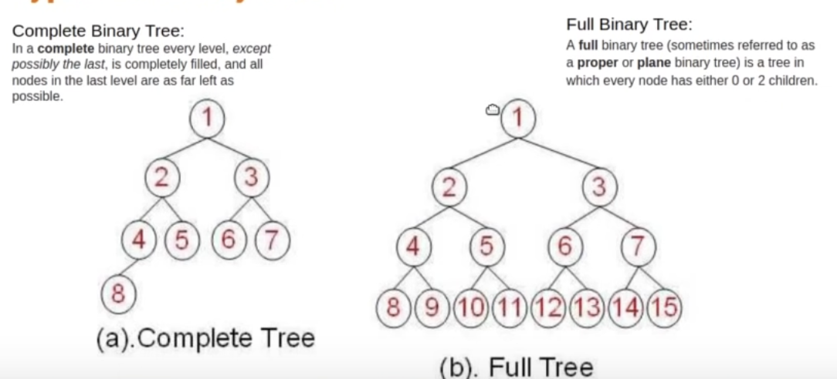

# **Data-Insertion**

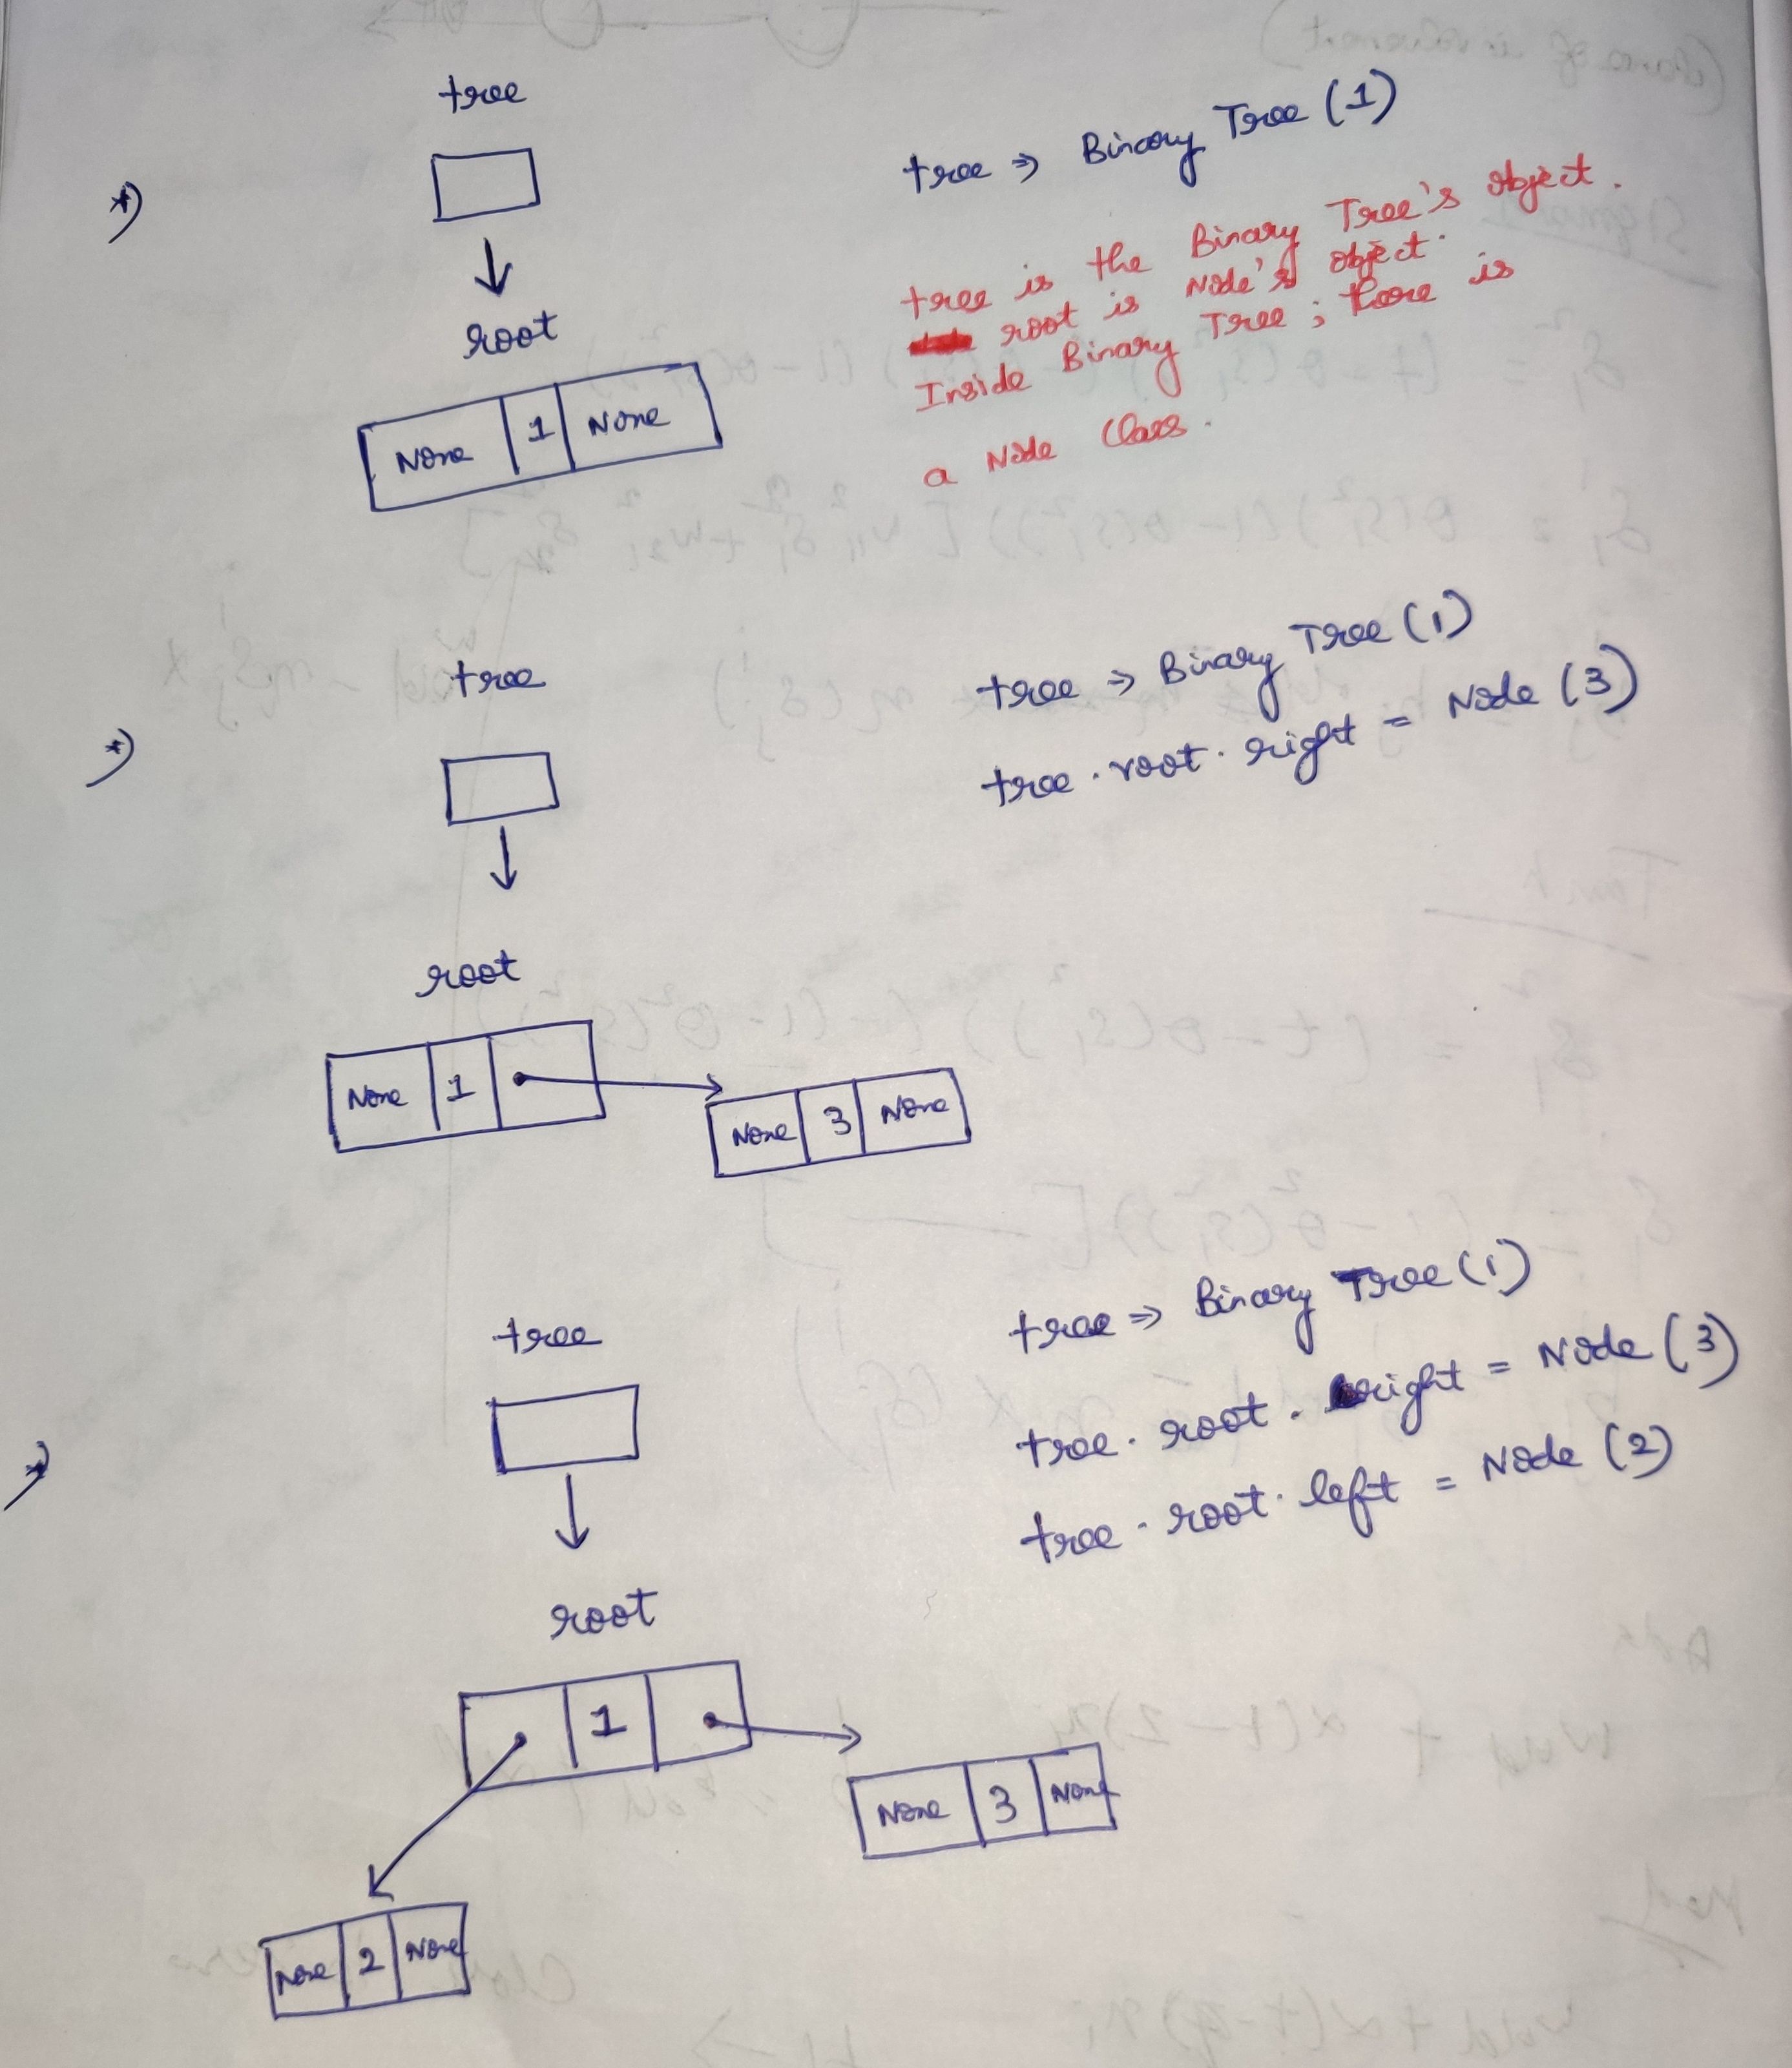

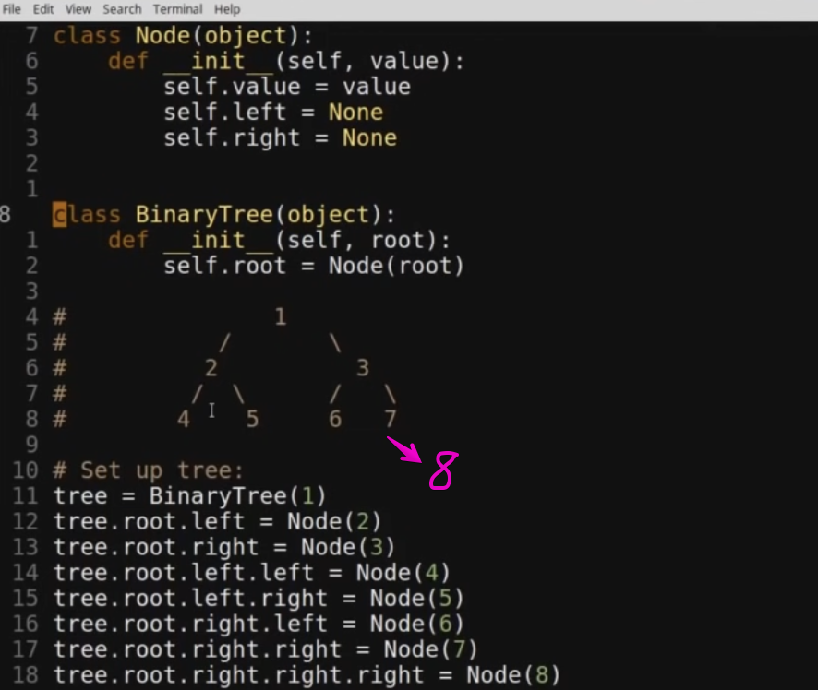

# **Tree-Traversal**

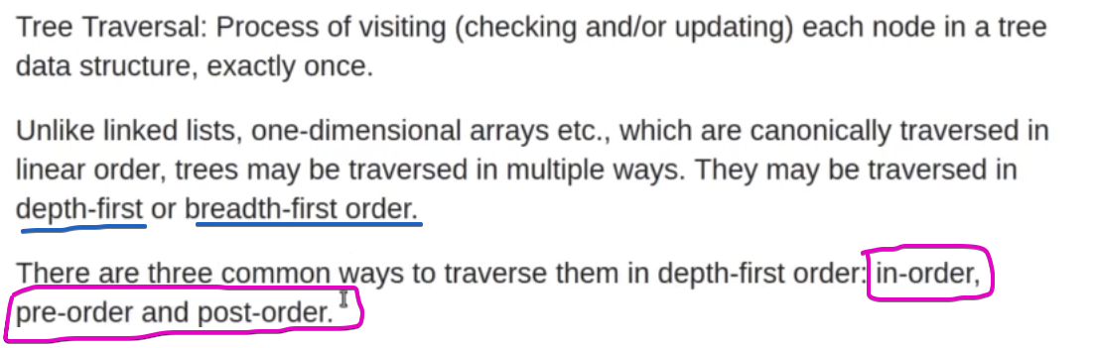

## **Pre-order Traversal**

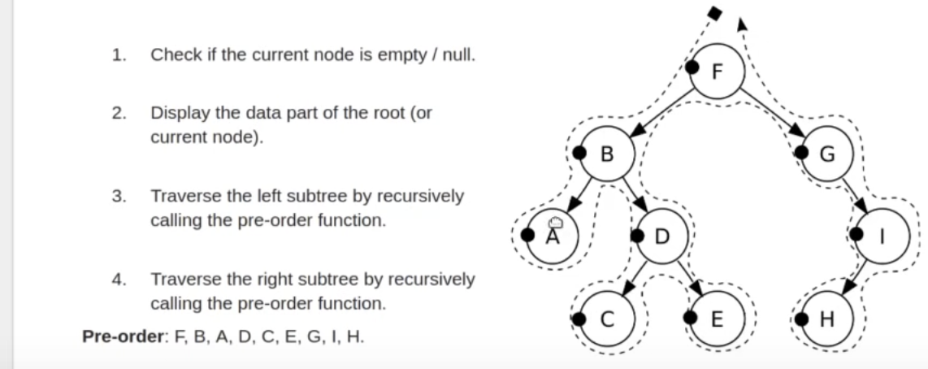

## **In-order Traversal**

## **Post-order Traversal**

# **Reference**

<https://www.youtube.com/playlist?list=PL5tcWHG-UPH112e7AN7C-fwDVPVrt0wpV>